

CA Clarity PPM v13.1

Strategic Alignment Documentation  
Release 3.3 – Installation Procedure

**Table of Contents**

1. Installation Instructions 3

1.1. Pre-reqs 3

1.2. Installing the Application 3

1.3. Post-installation procedures 4

1.4. Installing Demo Data 5

1.5. Demo Data Post-Installation 6

2. Technical Summary 9

2.1. Object Description 9

2.2. Pages 10

2.3. Processes 11

# Installation Instructions

## Pre-reqs

Strategic Alignment assumes:

1. You have XOG v13 installed
2. You have a user called “xog” that has a password “gox” with **all access rights** to xog stuff in.   
   The v13 CAW Dataset **DOES NOT** have it. **YOU MUST** create the XOG user with GOX as its password and add it to the “**Administrator - All Rights**” group.

## Installing the Application

1. Download the Strategic Alignment ZIP file from the CA Wiki page.
2. Unzip the package file into your c:\temp folder.
3. Navigate to C:\Temp\StratAlignment_v3_3
4. Right-Click the file “StratAlignment_v3_3Install.bat” and select “Edit” from the Drop Down Menu
5. Locate the line where the XOG_HOME variable is set and replace the path to reflect your XOG installation path
6. Locate the line where the SERVERNAME variable is set and replace the value with your server name or IP address
7. Locate the line where the PORTNUMBER variable is set and replace it with the appropriate value (normally, it’s 80)
8. Locate the line where the USERNAME variable is set and replace it with the username you will use (default is the ‘xog’ user)
9. Locate the line where the PASSWORD variable is set and replace it with the password for that user (default is ‘gox’)
10. Save this file
11. Run the file by double-clicking it.
12. Navigate to C:\Temp\StratAlignment_v3_3\output
13. Check all the output files for errors.
14. You shouldn’t see any errors. If you do, try to verify the reason and correct it. It’s ok to run it again after you correct something. If you don’t find the problem, drop me a note and I’ll try to help you out.
15. Security warnings for Pages and Portlets are normal – they will be corrected when the Groups are loaded. Security warnings for Groups are also normal – they will be corrected when Seed Data is loaded.

## Post-installation procedures

1. Login to Clarity with “Admin”
2. Go to the Admin tool
3. Click on Processes
4. Filter all processes starting with “Strat”.
5. Activate the following processes by clicking on them, navigating to “validation” and clicking on “Validate All and Activate”. Other processes may temporarily exist but you should ignore them.
   1. Strategic Alignment Metric Initialize
   2. Strategic Item – Build Tree Flat
   3. Strategic Item – Clean up Tree
   4. Strategic Item – Rebuild Tree
   5. Strategic KPI Calculation
   6. Strategy Control

## Installing Demo Data

1. After installing the application, if demo data is necessary, follow these steps
2. Right-Click the file “StratAlignment_v3_3Install_Demo.bat” and select “Edit” from the Drop Down Menu
3. Locate the line where the XOG_HOME variable is set and replace the path to reflect your XOG installation path
4. Locate the line where the SERVERNAME variable is set and replace the value with your server name or IP address
5. Locate the line where the PORTNUMBER variable is set and replace it with the appropriate value (normally, it’s 80)
6. Locate the line where the USERNAME variable is set and replace it with the username you will use (default is the ‘xog’ user)
7. Locate the line where the PASSWORD variable is set and replace it with the password for that user (default is ‘gox’)
8. Save this file
9. Run “StratAlignment_v3_3Install_Demo.bat”

## Demo Data Post-Installation

To finish installing demo-data, follow these steps:

1. As an Admin, login to the application. Navigate to “Evaluation Cycles” under “Strategic Alignment”

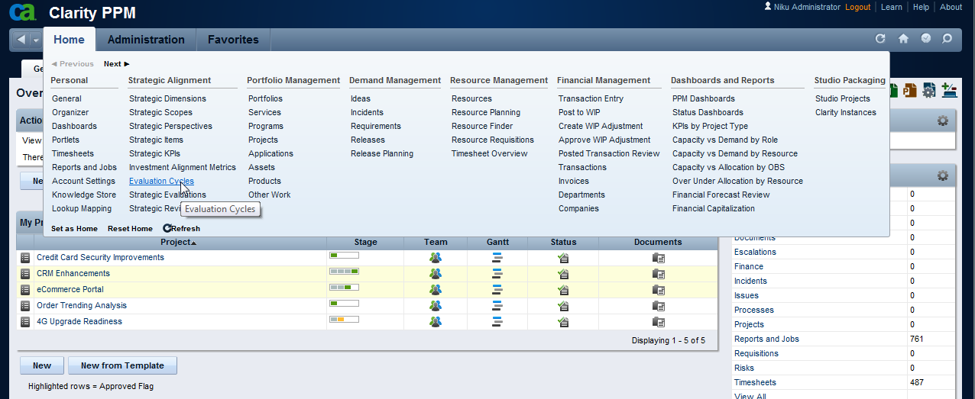

1. You’ll see three different cycles. Repeat this step for each one of them

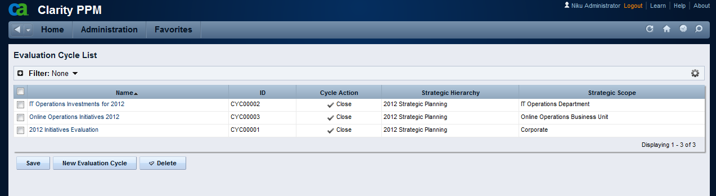

1. Open one of the Cycles. Click on the Processes Tab

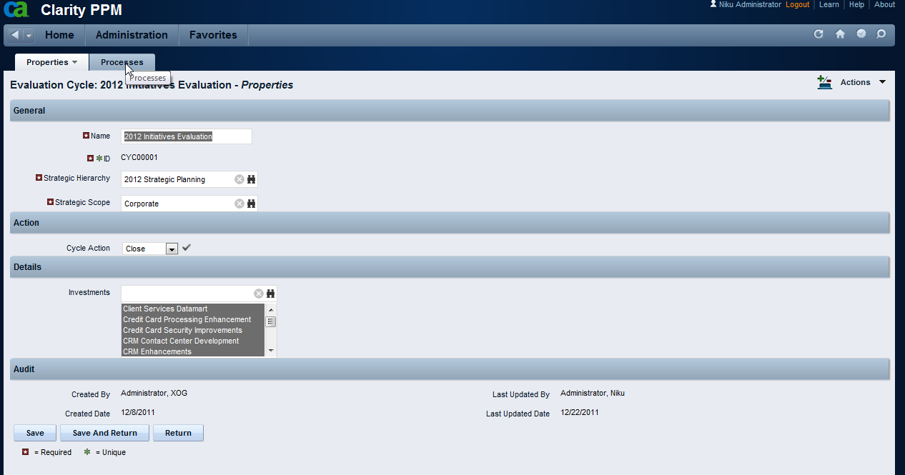

1. Click on the Process tab again and navigate to the Available processes page

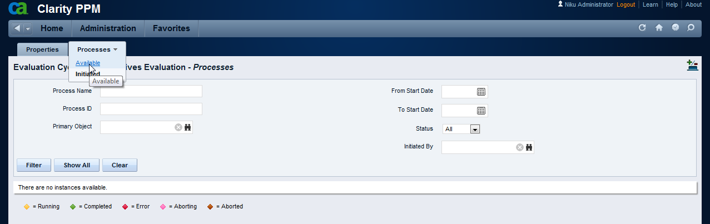

1. Mark the checkbox for the “Strategy Control” process and click the “Start” button.

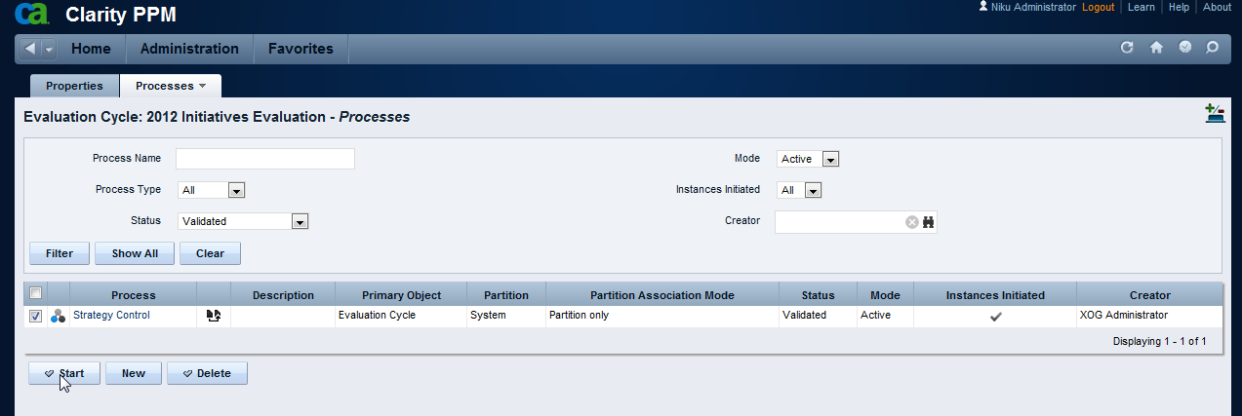

1. Wait until the process is finished, and repeat these steps for the other two cycles.

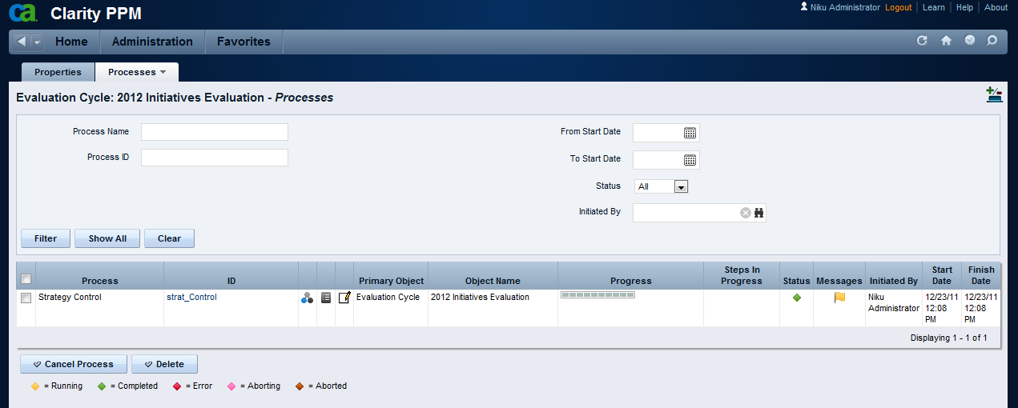

1. The installation process of Demo Data is now complete.

# Technical Summary

## Object Description

|  |  |  |  |  |
| --- | --- | --- | --- | --- |
| **Object** | **ID** | **Master – Subobject** | **Description** | **Additional information** |
| Strategic Dimension | strat_dim | Master Object | Dimensions are types of Strategic Maps and are related to Alignment Attributes in the Investment Object.  e.g. The “Department” dimension will be used to calculate the “Department Alignment Score” | Three Dimensions are delivered as “Seed Data”:   * Department; * Business Unit; * Corporate   Additional dimensions can be easily created |
| Strategic Scope | strat_scope | Master Object | Scopes are instances of dimensions.  e.g. The “IT Operations Department” is a scope that allows the IT Strategy Team to build an IT Strategy, either stand-alone or linked to a Corporate Strategy Plan. | Five Scopes are delivered as “Seed Data”. |
| BSC Perspective | strat_bsc_persp | Master Object | BSC Perspectives are aligned to the Balanced Scorecard tool.  e.g. the “Customer” perspective. | Four Perspectives are delivered as “Seed Data”:   * Financial; * Customer; * Internal Processes; * Learning and Growth |
| Strategic KPI | strat_kpi | Master Object | KPIs are used to set targets and capture measurements on Key Indicators related to your Strategic Plan. KPIs are scope-specific.  e.g. “Customer Satisfaction Index” is a Key Indicator of the “Corporate Strategy” scope; “IT Customer Index” is a Key Indicator of the “IT Operations” scope | KPIs are delivered as “Demo Data” |
| KPI Target | strat_kpi_target | Subobject to Strategic KPI | Targets are used to establish your goals for a specific period.  e.g. We set a Target of “95” for “Customer Satisfaction Index” KPI at the end of 2011, “97” at the end of 2012, “99” at the end of “2013” | Targets are delivered as “Demo Data”. Demo targets are set by Year. |
| KPI Measurement | strat_kpi_measure | Subobject to Strategic KPI | Measurements are used to assess how we’re comparing to our targets  e.g. We have measured “Customer Satisfaction Index” on Q1 2011 as “90” and Q2 2011 as “92” | Measurements are delivered as “Demo Data”. Demo measures are set by Year, Quarter or Month, depending on the nature of the KPI. |
| Strategic Item | strategic_item | Master Object | Strategic Items are the “heart” of the system. Items are created and can be related to each other in a parent-child relation building a “Strategic Hierarchy”. Some facts about Strategic Items:   * Items are related to a Scope; * Items may be related to a Perspective; * Items are classified in Levels; * Items may have a Parent Item; * Items may be related to KPIs (that monitor their execution) * Items may be related to Alignment Metrics (that help evaluate Investments against those items) |  |
| Investment Alignment Metric | strat_align_metric | Master Object | Alignment Metrics are used to assess Investments (Ideas, Projects, Programs, etc) against the Strategic Items in your Strategic Plan.  e.g. “$ Cost Reduction” | Alignment Metrics are delivered as “Demo Data”. |
| Alignment Scale | strat_metric_scale | Subobject to Investment Alignment Metric | The Metric Scale is used to normalize different Metrics in a way they can all be compared and used in a formula.  e.g. $ Cost Reduction of 500,000 is “Above Average”, giving an alignment score of “60” | Alignment scales are part of the Alignment Metrics “Demo Data”. |
| Evaluation Cycles | strat_eval_cycle | Master Object | Evaluation Cycles are used to Evaluate initiatives against your Objectives by using the Alignment Metrics associated with those Objectives. | Three evaluation cycles, one for each Dimension, are delivered as “Demo Data”. |
| Strategic Evaluations | strat_evaluation | Master Object | Strategic Evaluations are created automatically by Workflow during the execution of a cycle. They contain a “Question” about an “Investment” that should be answered by the Investment’s Manager according to the Investment Business Case. They are subject to instance-based security – only the Investment Manager can Edit these records (as well as the Administrator) | Strategic Evaluations for the three Evaluation Cycles are delivered as “Demo Data” |
| Strategic Tree Flat | strat_tree_flat | Master Object | This object is generated automatically via Workflow and is just used as an auxiliary table for building Multi-Scope Portlets. Users should NOT have access to this object in the UI. | Strategic Tree Flat items are delivered as part of “Demo Data” referring to Strategic Items and the three Scopes. |

## Pages

|  |  |  |  |
| --- | --- | --- | --- |
| **Page** | **ID** | **Custom TABs** | **Description** |
| [BSC Perspective Default Layout](http://claritylatam50/niku/nu#action:npt.getPage&pageId=odf.strat_bsc_perspFrame&id=5009062&obsType=Page&principal_type=SYSTEM&principal_id=0) | odf.strat_bsc_perspFrame | Dashboard | Portlets showing Strategic Items Hierarchy and Projects Hierarchy related to that BSC Perspective |
| [Evaluation Cycle Default Layout](http://claritylatam50/niku/nu#action:npt.getPage&pageId=odf.strat_eval_cycleFrame&id=5009056&obsType=Page&principal_type=SYSTEM&principal_id=0) | odf.strat_eval_cycleFrame | n/a |  |
| [Investment Alignment Metric Default Layout](http://claritylatam50/niku/nu#action:npt.getPage&pageId=odf.strat_align_metricFrame&id=5009038&obsType=Page&principal_type=SYSTEM&principal_id=0) | odf.strat_align_metricFrame | n/a |  |
| [Strategic Dimension Default Layout](http://claritylatam50/niku/nu#action:npt.getPage&pageId=odf.strat_dimFrame&id=5009044&obsType=Page&principal_type=SYSTEM&principal_id=0) | odf.strat_dimFrame | n/a |  |
| [Strategic Evaluation Default Layout](http://claritylatam50/niku/nu#action:npt.getPage&pageId=odf.strat_evaluationFrame&id=5009050&obsType=Page&principal_type=SYSTEM&principal_id=0) | odf.strat_evaluationFrame | n/a |  |
| [Strategic Item Default Layout](http://claritylatam50/niku/nu#action:npt.getPage&pageId=odf.strategic_itemFrame&id=5009020&obsType=Page&principal_type=SYSTEM&principal_id=0) | odf.strategic_itemFrame | Dashboard | Portlets showing Strategic Items Hierarchy and Projects Hierarchy related to that Strategic Item |
| [Strategic KPI Default Layout](http://claritylatam50/niku/nu#action:npt.getPage&pageId=odf.strat_kpiFrame&id=5009026&obsType=Page&principal_type=SYSTEM&principal_id=0) | odf.strat_kpiFrame | Dashboard | Portlets showing Strategic Items Hierarchy and Projects Hierarchy related to that Strategic KPI |
| [Strategic Review](http://claritylatam50/niku/nu#action:npt.getPage&pageId=strat_ReviewFRAME&id=5009067&obsType=Page&principal_type=SYSTEM&principal_id=0) | strat_ReviewFRAME | Strategic Review  Strategic Projects  Strategic KPIs  Evaluation Cycle Results | Hierarchy of Strategic Items with their KPIs  Hierarchy of Strategic Items with their supporting Projects  KPI Targets and KPI Measurements information  Investment Alignment calculation from Evaluation Cycles |
| [Strategic Scope Default Layout](http://claritylatam50/niku/nu#action:npt.getPage&pageId=odf.strat_scopeFrame&id=5009032&obsType=Page&principal_type=SYSTEM&principal_id=0) | odf.strat_scopeFrame | n/a |  |
| [Strategic Tree Flat Default Layout](http://claritylatam50/niku/nu#action:npt.getPage&pageId=odf.strat_tree_flatFrame&id=5009014&obsType=Page&principal_type=SYSTEM&principal_id=0) | odf.strat_tree_flatFrame | n/a |  |

## Processes

|  |  |
| --- | --- |
| **Process** | **Description** |
| Strategic Alignment Metric Initialize | Every time you create a new Investment Alignment Metric this process creates a blank set of “Alignment Scales” From Null (0) to Extraordinary (100) |
| Strategic Item – Build Tree Flat | Every time you change a Strategic Item this process will create records in the Strategic Tree Flat table with the Item’s parents and children in all levels up and down. |
| Strategic Item – Clean up Tree | Every time you delete Strategic Items you should manually execute this process to Clean Up the Strategic Tree Flat table |
| Strategic Item – Rebuild Tree | Use this to rebuild the Strategic Tree Flat table in case of need (Example: if you XOG in new Strategic Items) |
| Strategic KPI Calculation | Every time you change KPI Targets or KPI Measurements you should run this process manually to update their “KPI Status” attribute and the Strategic Item’s KPI Status attribute |
| Strategy Control | Every time you create a Strategic Cycle this process will help Distribute the Evaluation Questions; once they are answered it will Calculate Weights, Calculate the Alignment Scores and Update Investments. |